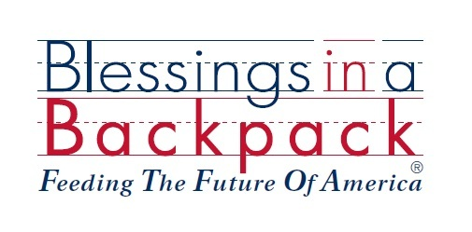

Organization Statement

Blessings in a Backpack is a results-oriented program, designed to feed elementary school children whose families qualify for the Federal Free and Reduced Price Meal program, and have little or no food on the weekends. Better test scores, improved reading skills, positive behavior, improved health and increased attendance have all been attributed to the success of this program.

$100 feeds an American school child in the program for an entire 38 week school year. A passionate volunteer elects to start the Blessings in a Backpack program in a local school. S/he fundraises to support the number of children in the program and partners with a nearby grocery vendor. Blessings in a Backpack donates the backpacks for the program, so 100% of the money raised by the program coordinator goes directly to food purchased for the backpacks. Every Friday, students receive their backpacks with staples that require little to no preparation. They return with their backpacks on Monday ready to learn.

Blessings in a Backpack has experienced explosive growth during the last several years. As of September 1, 2015, we are feeding 78,000 children in 45 states and Washington DC. The organization could not have achieved this milestone without our tireless volunteers, dedicated school personnel, or valued public, corporate, athletic, and celebrity sponsors. Our goal is to continue to continue to grow into 2016 and beyond. Together, we are Feeding the Future of America, one school at a time.

Please visit our website at www.blessingsinabackpack.org for more information

