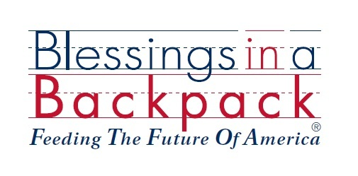

Dear PARENT,

Your child is eligible to be a recipient of the Blessings in a Backpack program and once the program is implemented will receive a backpack of non-perishable food every Friday. Backpacks will be dispensed in a discreet and caring manner. This program runs the full 38 week school year. If you wish for your child to participate in the program you do not need to do anything other than have your child return the backpack every Monday so we can continue to send home on Fridays. There is no cost associated to this program. If you choose to opt out of this program please sign below and return the letter to the school.

Thank you!

Signature
I do not want my child to participate in the Blessings in a Backpack program.

